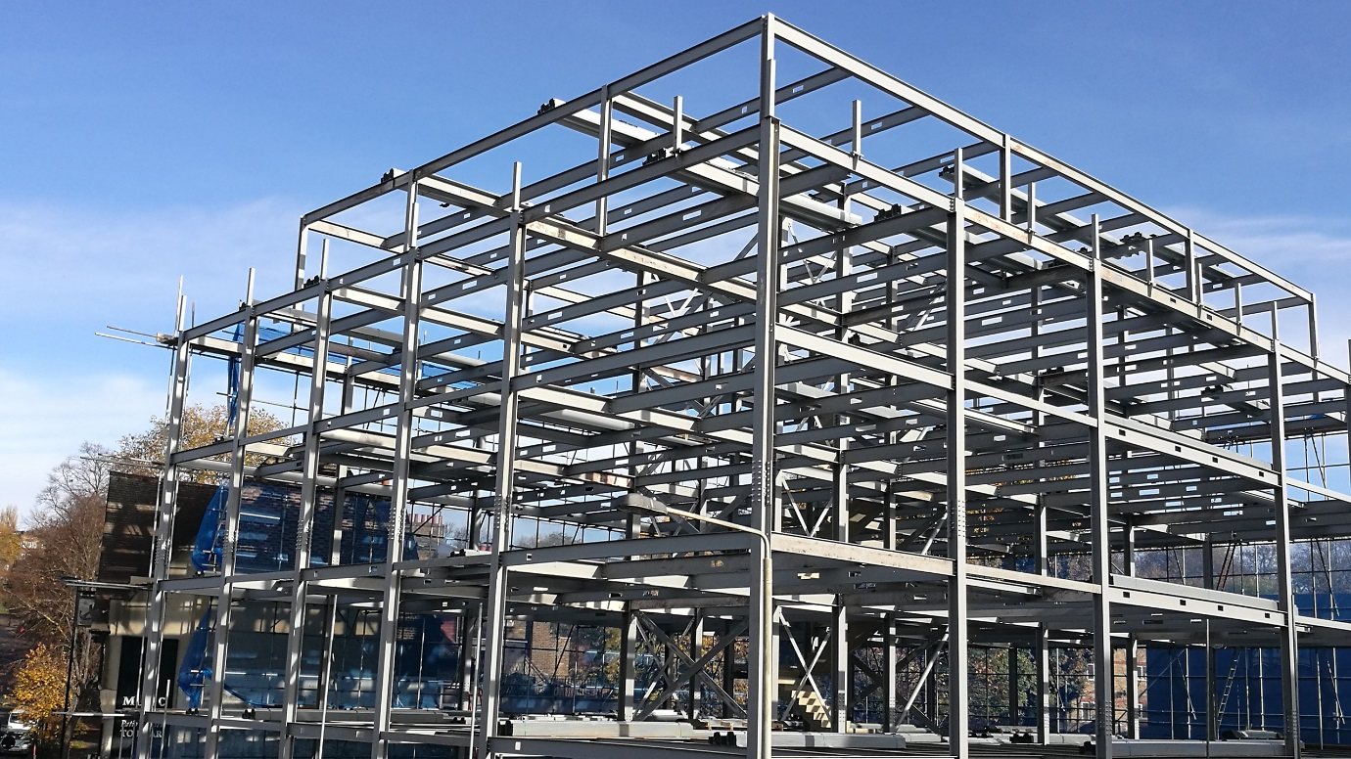
London November 2016
The structural framework of The Isabella Apartments, designed by Timothy Associates, is now complete
The 28-unit block of apartments in Lewisham town centre is being constructed in partnership with the London Borough of Lewisham and is part funded by the Mayor of London.
The building will provide a mix of 8 one-bedroom apartments, 16 two-bedroom apartments and 4 three-bedroom apartments, all with generous balconies and/or private roof terraces. The ground floor retail accommodation will have a new entrance and reception located on Lewisham Road.
Completion of the apartment block is due to take place in 2017.
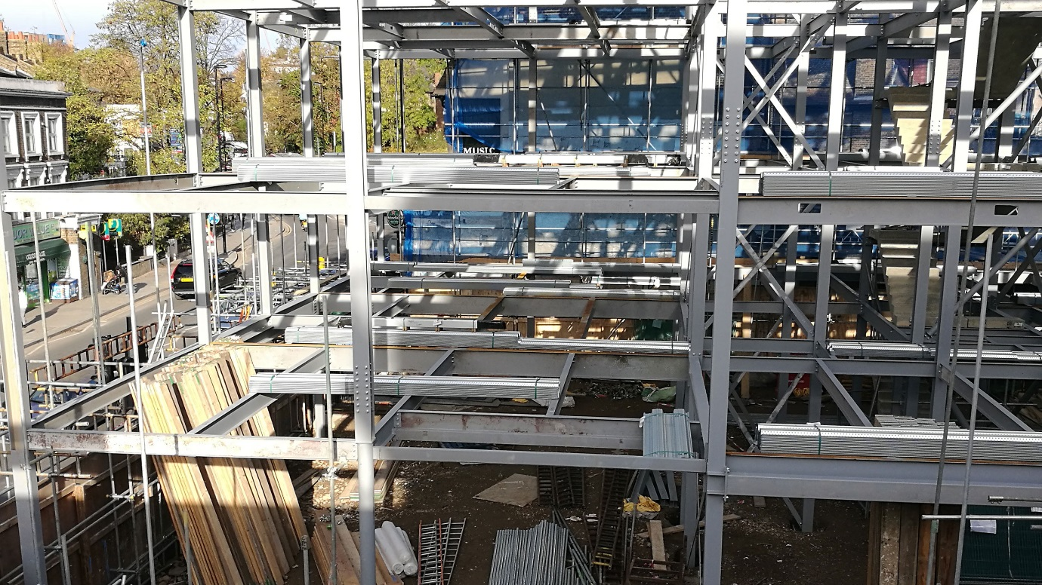
The Isabella Apartments will complement the recently completed Lewisham Premier Inn, also designed by Timothy Associates.
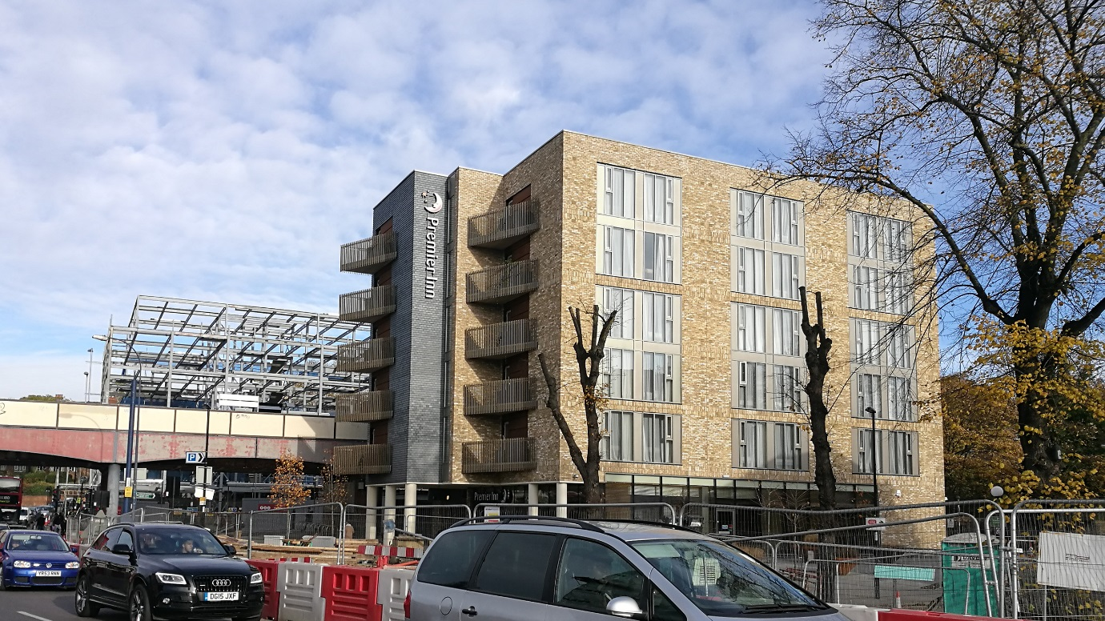

Ends

Read more

Notes to Editors:
1. For further press information contact Erica in the Timothy Associates Press Office. Tel: 020 7403 2482 Email: studio@timothy.co.uk

2. To request additional images of the building please email: arthur@timothy.co.uk

Posted on 22 November 2016

About Timothy Associates:

Timothy Associates are architects, landscape architects, urban planners, and design theorists who promote a humane and comprehensive design philosophy. In keeping with a design approach that we have applied to all our projects, the design of each of our projects responds to local historic, cultural, and environmental contexts and grows out of a vision of how it can affect the lives of the individuals for whom the buildings and public spaces are created. Arthur and Erica Timothy are lead architects and designers on all projects by Timothy Associates and we participate in an iterative design process, working closely with the client and consultants to test each new project’s brief, refine design ideas, and facilitate the development of appropriate and effective solutions. Timothy Associates is committed to architecture that supports and enhances a project’s brief; that is informed by social, geographic, and cultural elements that define a place; and that responds to human needs and aspirations.
The practice has designed and continues to create a range of projects including residential, leisure, cultural, civic, educational institutions; mixed-use buildings, and master plans. Arthur Timothy established his practice in 1986 after working on a number notable projects including the design of The Hay’s Galleria. The practice soon gained public attention with its urban regeneration projects in depressed areas of south east London. Timothy Associates gradually extended its expertise and now works on a wide range of projects at a variety of scales, always providing clients with the highest standards of service, adding value and exceeding clients’ expectations. We seek to work with clients who are ambitious and interested in pushing boundaries to create outstanding architecture.

Ends

