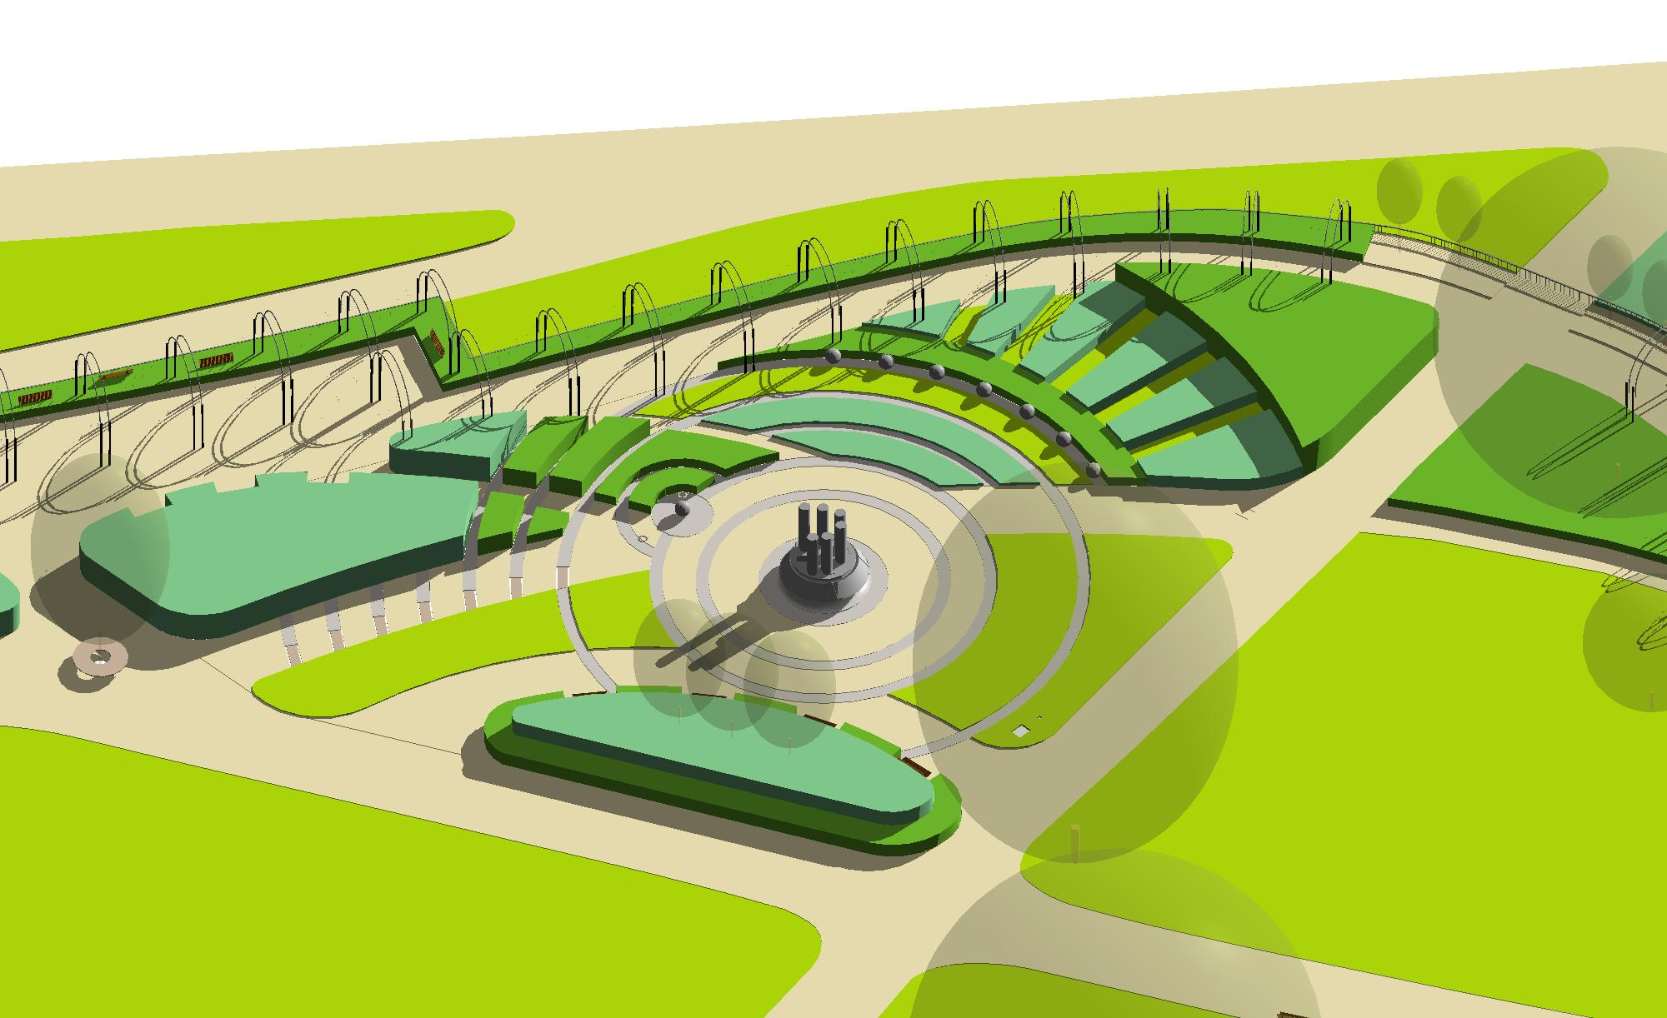

London November 2016 - Timothy Associates’ design for a memorial garden to remember enslaved Africans and their descendants, on a prominent site in London’s Hyde Park, was granted planning permission on 8th November 2016.
The proposal was supported unanimously by the City of Westminster. The Councillors stated that the memorial deserved a prominent position. They were …“fully supportive”… it was “fantastic” …. “absolutely brilliant”… and they were …“delighted to support this exceptional design”…
The Client: Memorial 2007 is now actively fund-raising in order to realise this important project. Anyone interested in supporting the project should contact Memorial 2007 : http://www.memorial2007.org.uk/
The statue and memorial garden - on a site in the Rose Gardens of London's Hyde Park - will be the first national memorial anywhere in the world to commemorate enslaved Africans and their descendants. It will become a place for reflection and education and will form part of the UNESCO World Slave Route Heritage Project linking the key global sites associated with the slave trade.
The site is located within the renowned ‘Rose Garden’ and the proposal has been carefully designed to blend with and enhance the existing garden, whilst also having its own theme, including some exotic flora appropriate to the setting and the subject. Timothy Associates has worked closely with the Royal Parks in agreeing the planting plans.
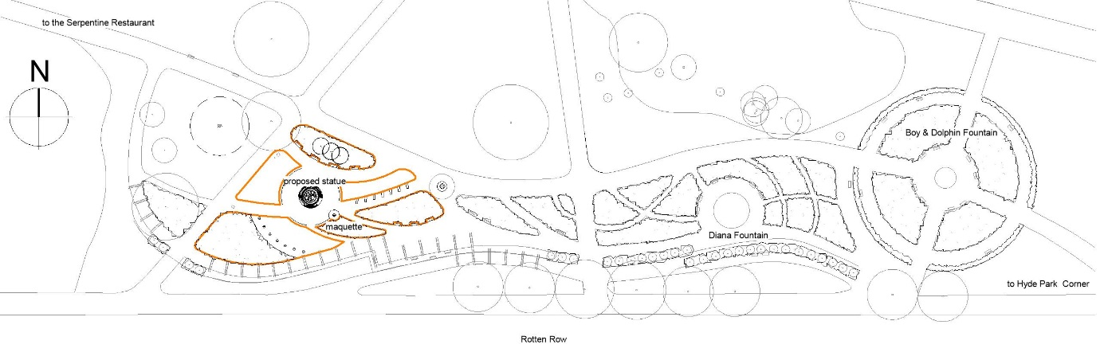
The concept for the design is based on the ‘Slave Trade Triangle’. It is sub-divided it into three zones representing Europe, Africa and America, with the sculpture located in the central space which represents the Atlantic Ocean. Rings of granite bands radiate out from the sculpture, linking the three continents. The ‘coast’ of the ‘Americas’ is marked by a line of granite balls, linked with heavy chain to symbolize the ‘Middle Passage’, the terrible Atlantic Crossing from Africa to America where so many slaves perished.

The contrast between these three continents is emphasised by the planting, with old fashioned roses and soft pinks and mauves in the European zone:
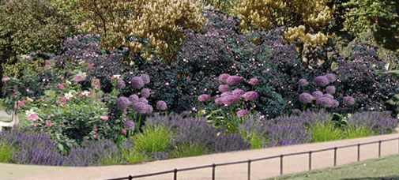

bright hot colours and bold architectural textures in the Africa zones, and
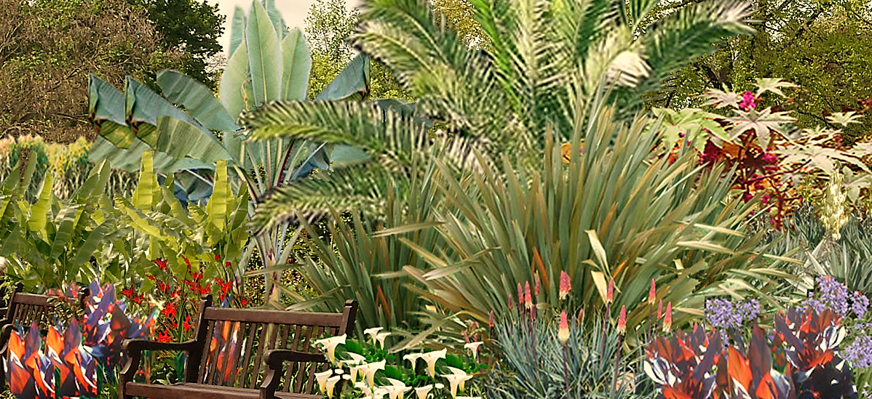
simple blocks of planting representing the sugar and tobacco plantations in the Americas zone.
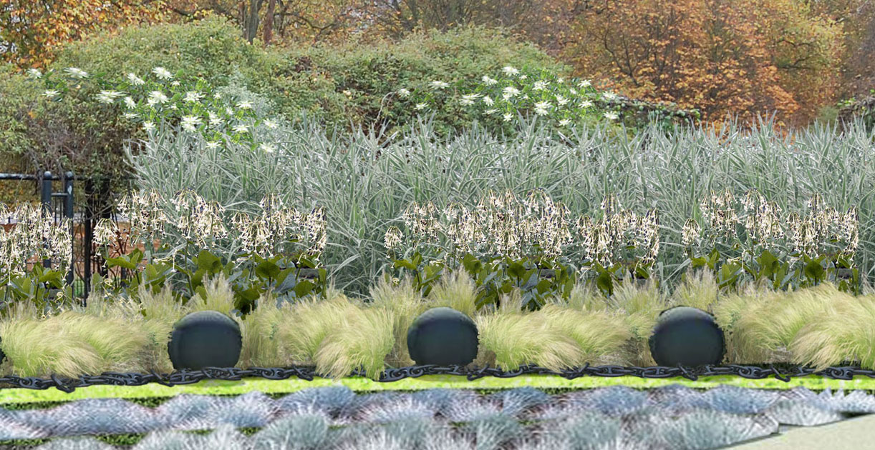

The garden is designed around a new bronze sculpture designed by Les Johnson FRBS, and selected by competition.
A new central paved space will allow for informal gatherings and encourages circulation and contemplation of the sculpture, whilst the three blocks of planting create enclosure. The memorial garden will be informative and will also be a space for quiet contemplation.
The memorial garden is both commemorative and educational, and seven large slate paving slabs inscribed with key dates will be set into the path leading to the central sculpture

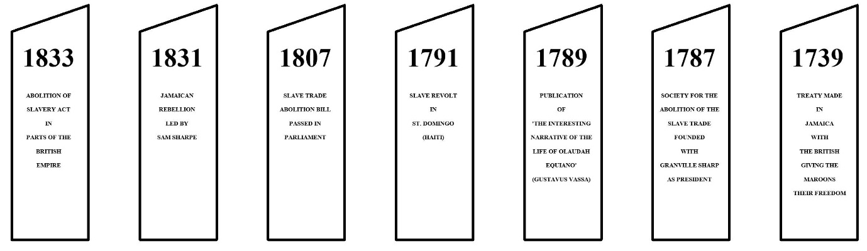

An inscription on the central statue will read
"They will remember that we were sold But they won’t remember that we were strong, They will remember that we were bought, But not that we were brave" – WLLIAM PRESCOTT, FORMER SLAVE 1937
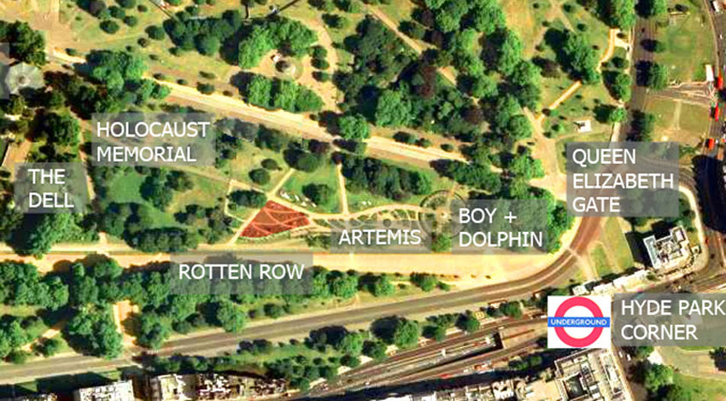

Ends

Read more

Notes to Editors:
1. For further press information contact Erica in the Timothy Associates Press Office. Tel: 020 7403 2482 Email: studio@timothy.co.uk

2. To request additional images of the building please email: arthur@timothy.co.uk

Posted on 22 November 2016

About Timothy Associates:

Timothy Associates are architects, landscape architects, urban planners, and design theorists who promote a humane and comprehensive design philosophy. In keeping with a design approach that we have applied to all our projects, the design of each of our projects responds to local historic, cultural, and environmental contexts and grows out of a vision of how it can affect the lives of the individuals for whom the buildings and public spaces are created. Arthur and Erica Timothy are lead architects and designers on all projects by Timothy Associates and we participate in an iterative design process, working closely with the client and consultants to test each new project’s brief, refine design ideas, and facilitate the development of appropriate and effective solutions. Timothy Associates is committed to architecture that supports and enhances a project’s brief; that is informed by social, geographic, and cultural elements that define a place; and that responds to human needs and aspirations.
The practice has designed and continues to create a range of projects including residential, leisure, cultural, civic, educational institutions; mixed-use buildings, and master plans. Arthur Timothy established his practice in 1986 after working on a number notable projects including the design of The Hay’s Galleria. The practice soon gained public attention with its urban regeneration projects in depressed areas of south east London. Timothy Associates gradually extended its expertise and now works on a wide range of projects at a variety of scales, always providing clients with the highest standards of service, adding value and exceeding clients’ expectations. We seek to work with clients who are ambitious and interested in pushing boundaries to create outstanding architecture.

Ends

